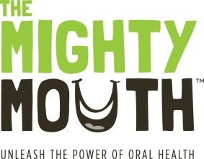
The Mighty Mouth Minute

Good oral health is a critical part of your overall health.
Take a minute to learn how you can prevent oral disease.

Save your smile - give your teeth time to rest
Reduce “time on teeth”

Here is one more reason to keep your hand out of the chip bag - and this one may surprise you. Frequent snacking doesn’t just affect your waistline it can also cause major problems for your teeth, harming both your smile and your overall health.

- Snacking or drinking sweet or acidic beverages (even diet soda and sports drinks), frequently throughout the day can lead to cavities.

- Here is another twist, it is not just sugary foods that cause cavities. Even snacks that we think of as “healthy”, such as bagels, juice, granola bars and raisins, contribute to decay if they are consumed too often.

- Teeth need time to rest and rebuild in between drinking and eating. Just like your muscles need time to recover after exercising.

- Sweet or high carbohydrate foods and sweet drinks feed the germs that cause cavities. These germs make acids that eat into your teeth leading to decay. These “acid attacks” last for 20 minutes after you eat or drink.

- Drinking (anything other than water) and snacking or "grazing” frequently during the day means food and drink are on your teeth for a long time. This leads to costly, and sometimes painful, cavities.

- When you snack, eat tooth-friendly foods such as fruit, vegetables and cheese. Your waistline will benefit, and so will your oral and overall health.

Unleash the power of oral health!
To learn more, visit TheMightyMouth.org

