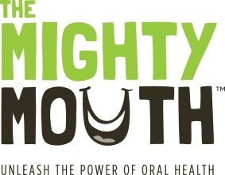
The Mighty Mouth Minute

Good oral health is a critical part of your overall health.
Take a minute to learn how you can prevent oral disease.

Flossing is the New Yoga
Unleash the power of the tiny string
While a toothbrush cleans the surface of your teeth, only floss removes what lurks in between, and under the gumline. All the grooming in the world won’t help if you have a piece of spinach stuck in your teeth, or if you have bad breath because of a gum infection.

Daily flossing and brushing helps you look and feel better by:
- preventing cavities and gum infections
- keeping your breath fresh
- helping you look younger (by helping to prevent gums from receding)

- Flossing is easy. It only takes a couple of minutes, less time than it takes to shave or apply mascara.

- Flossing saves you money. Every cavity prevented saves you more than $2,000 over a lifetime.

- Take care of your teeth and gums by wrapping them in a floss embrace every day. Your oral and overall health will improve – and so will your breath.

Unleash the power of oral health!
To learn more, visit TheMightyMouth.org

