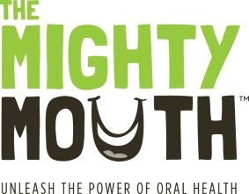
The Mighty Mouth Minute

Good oral health is a critical part of your overall health.
Take a minute to learn how you can prevent oral disease.

“Dry Mouth” can lead to serious oral disease
Some medications and health conditions, such as diabetes, can cause your mouth to become overly dry.
Symptoms of dry mouth:
- Frequent thirst, bad breath, cracked lips and sore throat

How dry mouth affects you:
- Causes painful and costly root cavities
- Leads to gum disease, which is linked to heart disease, stroke and diabetic complications

What to do if you have “dry mouth”
- Drink extra water (fluoridated water is best)
- Use a saliva substitute
- Chew sugarless gums and mints (especially those with xylitol, a natural sweetener that protects teeth).
- Protect your teeth with fluoride (rinses, toothpaste, varnish)
- Get regular oral health checkups
- Tell your dentist and physician that your mouth is dry

What you should avoid:
- Candy and cough drops (unless they are sugar free)
- High sugar drinks including juice, sports drinks and sodas (even diet)
- Drinks with caffeine or alcohol
- Tobacco

Your oral health is important: make sure you brush twice a day, floss daily, get regular oral health checkups and engage in smart snacking.

Unleash the power of oral health!
To learn more, visit TheMightyMouth.org

