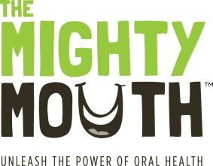
The Mighty Mouth Minute

Good oral health is a critical part of your overall health.
Take a minute to learn how you can prevent oral disease.

Dental care for pregnant women is important
Cavity-causing germs are infectious

Experts recommend that pregnant women get dental care and any needed treatment before their baby is born.

- The germs that cause tooth decay can be passed from mother to child. If moms have tooth decay, their babies have an increased risk for tooth decay.

- Studies have shown that mothers typically pass cavity-causing germs to their infants and toddlers through kissing or sharing food.

- Women who take care of their mouths and get regular dental care during and after their pregnancies can improve their children’s oral health, as well as their own.

When parents take steps to prevent oral disease they help their children toward a lifetime of better oral, and overall, health.

Unleash the power of oral health!
To learn more, visit TheMightyMouth.org

