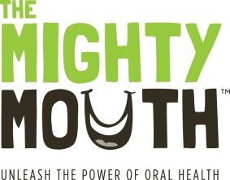
The Mighty Mouth Minute

Good oral health is a critical part of your overall health.
Take a minute to learn how you can prevent oral disease.

Baby teeth matter – protect your child’s oral, and overall health
Painful cavities make it difficult to eat, sleep, learn and play
Cavities are preventable
• Brush your child’s teeth twice a day.
• Use a small toothbrush and a smear of fluoride toothpaste.
• Don’t put your baby to sleep with a bottle of juice or milk. Use only water.
• By age one take your child to a dentist or physician for an oral health checkup.

Healthy snacking = healthier teeth
- Choose healthy snacks such as cheese, fruits and vegetables.
- Sweet liquids including juice, sport drinks and soda (even diet), cause cavities.
- Avoid “grazing”--snacking and drinking sweet liquids throughout the day.
- Teeth need time to rest in between eating and drinking.

If a child is cavity-free prior to age three, he/she is more likely to have better oral health for a lifetime.

Unleash the power of oral health!
To learn more, visit TheMightyMouth.org

