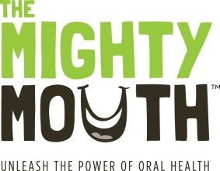
The Mighty Mouth Minute

As you plan for healthy aging keep in mind you’re not healthy without a healthy mouth. And remember, basic Medicare does not cover dental care.

Oral health is an important part of healthy aging, so be sure to include dental expenses in your retirement planning. Oral disease is linked to serious health conditions including diabetes, heart disease and stroke.

Good oral health is especially important if you have diabetes or take daily medications.

Diabetes - If you have diabetes you are twice as likely to develop gum disease - and gum disease makes it harder to control blood sugar. Gum disease also can lead to tooth loss and bad breath. Be sure to tell your dentist if you have diabetes and talk to your physician about your oral health.

Medications - Many commonly prescribed and over-the-counter medications can cause dry mouth, a condition that can lead to root cavities and tooth loss. Dry mouth can make it hard to chew, swallow, and even speak. Be sure to talk with your healthcare providers and pharmacist about low-cost remedies to treat dry mouth.

To protect your oral - and overall - health:

Keep your mouth clean and healthy
- Floss every day
- Brush twice daily with fluoride toothpaste
- Use a mouth rinse with fluoride
- Drink fluoridated water instead of sugary drinks

Eat a well-balanced diet and choose healthy snacks:
- Low-fat cheese, fresh fruit, vegetables, nuts

Get regular dental checkups.
- Oral health problems are almost totally preventable
- Catching problems early saves you pain, time and money

With fluoridated water and better dental care more of us have the opportunity to keep our teeth throughout life. Take care of your mouth so you can stay healthy and eat the foods you love. Your quality of life will be better with a healthy mouth!

Unleash the power of oral health! To learn more, visit SeniorsOralHealth.org

