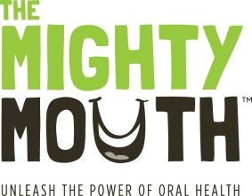
The Mighty Mouth Minute

Good oral health can help you manage your diabetes.
Take a minute to learn how you can stay healthy.

Gum disease is an infection that makes it harder to manage diabetes.
If you have diabetes you are twice as likely to develop gum disease and
gum disease makes it harder to control blood sugar.

Gum disease, usually caused by tartar or plaque, may cause your gums to become tender and bleed and can lead to tooth loss. Preventing gum disease will help you manage your diabetes, saving you and your pocketbook unnecessary pain.

To prevent gum disease:

Keep your mouth clean and healthy:
- Floss every day
- Brush twice daily with fluoride toothpaste
- Use a mouth rinse with fluoride
- Drink fluoridated water instead of sugary drinks

Eat a well-balanced diet:
Choose healthy snacks like:
- Low-fat cheese
- Fresh fruit
- Vegetables
- Nuts

Get regular oral health checkups as recommended by the American Diabetes Association.

Diabetes can lead to other problems in your mouth:
- Some diabetes medications can cause Dry Mouth, a condition that can make it hard to eat, taste, swallow, or even talk. Dry mouth can quickly lead to tooth decay, especially at the gumline. Let your dentist or physician know if you have dry mouth.

- You might develop painful Mouth Sores because wounds heal more slowly when you have diabetes.

Be sure to tell your dental provider if you have diabetes and discuss how often you may need routine oral health check-ups.
Unleash the power of oral health! To learn more, visit TheMightyMouth.org

